**Experimental Analysis of Spark Ignition Performance**

Christopher R. White

MWG: David Bedding, Jorge Godoy, Samuel Hordeski, Kevin Myers, Justin Sandler

Department of Mechanical Engineering

Lafayette College

Easton, PA 18042

**Abstract**

The majority of automobiles operate on the four-stroke internal composition (IC) engines, devices that transfer chemical energy via a spark ignition (SI) process into mechanical work to drive a piston. Since IC engines produce useful torque over a limited range of crankshaft rotational speeds, automobile engine manufacturers tests and analyze their products in order to optimize the design for desired torques. The purpose of this experiment was to determine the optimal shaft rotation speed ranges to achieve the maximum engine efficiency for a Briggs & Stratton V-Twin OHV engine while applying simulated parasitic loads via a water brake dynamometer. Crank shaft angle, torque, and pressure within the cylinder were measured for 3 complete cycles while applying fluid loads between minimum and maximum water flow rate interfaced with the crankshaft. The engine was tested at low, middle, and full throttles. This range of loadings between low end torque and high end torque was used to explore the effect of paracitic loadings. In this experiment, the performance was evaluated based on the torque curves under various loadings while maintaining constant throttle. The results were compared to published data from manufacturer [brigs Stratton data]. **The 60 bulb load is the most optimal loading as it resulted in the highest turbine efficiency of 59.9±2.6% with a cycle thermal efficiency of 1.14±0.57% and condenser effectiveness of 0.17±0.02.**

**Introduction and Methods**

The U.S. Energy Information Administration reports an increasing trend in nominal price of petroleum that has been present since 1998, when petroleum was $1.03 per gallon; it is now predicted to rise to a price of $2.73 per gallon by 2016[1]. The automotive industry is severely impacted by the increase in price as a result of the depletion supply of the Earth’s uncertain fossil fuel reserves. While designing an IC engine depends on the compromise between performance, fuel economy, and emissions, this study focuses soley on the performance of the engine. According to the law of conservation of energy, designing an engine of higher efficiency results in both environmental and economic incentives, since more energy is extracted from the fuel. In order to test and analyze a prototype IC engine, the Otto cycle is used to represent the actual four-stroke cycle as an idealized thermodynamic cycle with no internal irreversibilities. The Otto cycle is illustrated in Figure 1a and can be analyzed using the steady-flow energy equation, expressed as

${(q}_{in}-q_{out})-{(w}_{in}-w_{out})= h_{e}-h_{i}$ (kJ/kg) ⑴

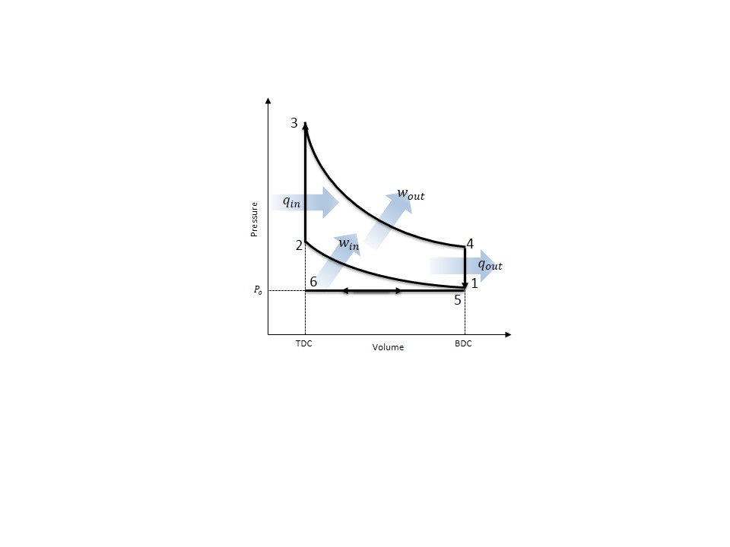where $q$ is heat transfer and $w$ is the work, and $h$ is the enthalpy at the exit and inlet of the control volume. The engine can be analyzed under the assumption that it is a steady-flow device and that the air behaves as an ideal gas.

**Figure 1: (a) P-V Diagrams for the Otto Cycle [5 replicated by White C.] and (b) Actual Four-Stroke Engine Cycle [5]**

The Otto cycle begins with process 6-1 as a fuel-air mixture is drawn into the cylinder isobarically as the piston travels from top dead center (TDC) to bottom dead center (BDC), resulting in an increase in the volume of the engine cylinder. The mixture is then isenropically compressed in process 1-2 as the piston travels from BDC to TDC resulting in an increase in the pressure. Heat is transferred isochorically to the mixture in process 2-3 via ignition from spark plug found in spark ignition (SI) engines.The fuel-air mixure expands in the cylinder performing work on the piston isentropically during the power stroke in process 3-4, drivein the piston from TDC to BDC. Heat is rejected isochorically from the engine in process 4-5 at BDC. The mass of spent fuel is expelled from the engine to the environment in process 5-6 through the exhaust stroke and the entire cycle repeats.

In the actual IC four-stroke cycle, the work between the piston and the fuel-air mixture is illustrated in Figure 1b and is determined through the integral of the product between the pressure within the cylinder and the differential volume, expressed as

$W_{p}=\oint{PdV}$ ⑵

Where $W_{p}$ is the work erxerted on the piston, P and $V$ are the pressure and the volume of the cylinder respectively. The volume can be determined from the geometrical relation expressed as

the actual **four-stroke spark-ignition engine**, differs from the Otto cycle in that it is characterized by gross work and net work

$V=(clearance+a+b+d3)(π\frac{{bore}^{2}}{4})$ ⑶

Where V is the volume of the cylinder, clearance is the distance between the top of the piston and TDC, a is the crank shaft length, b is the connecting rod length, d3 is the total distance from the crank shaft center to the bottom of the piston, and bore refers to the diameter of the piston.

Power of the cycle is determined using the numerical differentiation of work with respect to the sampling rate.

In the experimental set up, there are irreversabilities within the engine and which results in efficiencies for the engine. The brake work is the useful work is outputted by the engine output shaft, the associated mechanical efficiency of the engine is expressed as

$η=\frac{W_{b}}{W_{net}}$ = $\frac{τ×RPM}{W_{net}}$ ⑷

where $η$ is the engine efficiency, $W_{b}$ and $W_{net}$ are the brake work and the net work of the engine Wnet = pDV?

In the current study, engine efficiency was experimentally determined for low, middle, and full throttles.The actual cycle was compared to the idealized Otto cycle and published data in order to validate the experimental results.

The experiments were performed on a Briggs & Stratton V-Twin OHV engine with a **dynometer**. **Temperature, pressure, and mass flow rate** were measured at specific points in the cycle. The experimental schematic and locations of the instrumentation are illustrated in Figure 2.

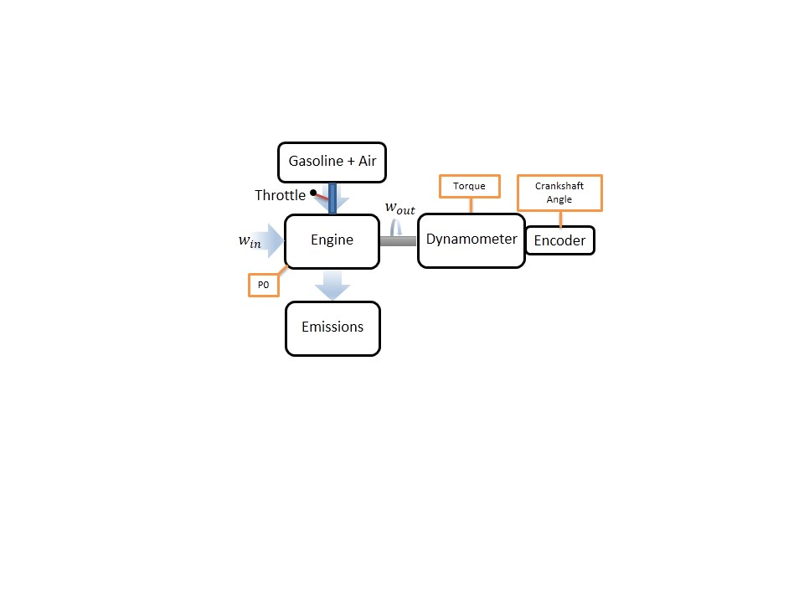

**Results and Discussion**

**Figure 2: Experimental 4-Stroke Engine Schematic with Instrumentation Locations: Pressure Transducer, Dynomometer Strain Gauge for Torque and Encoder for Crankshaft Angle [White C.]**

The following experiments were considered: (1) varyring fluid load at low throddle, (2) varyring fluid load at middle throttle, and (3) varyring fluid load at full throttle.

For each throttle case, the engine was started according to startup procedure in the Operating Instructions at a laboratory temperature of ____˚F and barometric pressure of _____ ksi [3]. The trottle lever was adjusted accordingly to the low, middle, or high throttle cases and maintained at the case position. A range of fluid loadings were applied to the output shaft via water brake dynamometer which were the mximum and minumem flow rates achieved by the dynomometer. The water mass flow rate was controlled via hand valve which was twisted for a total of ____ approimately equal turns for each loading. Approximately 50 data sets were reforded for each loading for each throttle cases. Since the engine does not reach a steaty state, loadings were applied at a constant rate and measurements were sampled for each loading at _____ Hz. Loading was incremented in sets of ______ order to observe the variation in turbine efficiency between low to high RPM. At the locations illustrated in Figure 2, crankshaft angle, torque, and pressure were measured for each load case. The work and heat transfer were determined using Eqs. (2-5) and P-V diagrams for each throttle case were generated actual four-stroke cycles in Figures 3-6. Data sampled at 28 kHz.

The engine efficiencies for the low, middle, or high throttle were **36.7±1.1%, 59.9±2.6%, and 58.8±3.9%** respectively. In addition, the **cycle efficiencies and condenser effectiveness** were determined using Eqs. (9 & 10) and are displayed in Table 1.

Based on the P-V curves for the actual four-stroke cycle for each throttle case are displayed in Figures 3-5.

**Figure 3: 20 Bulb Loading Temperature-Entropy Diagram for the Ideal Rankine Cycle (purple) and Actual Steam Turbine Cycle (blue)**

This is attributed to the additional components in the actual cycle as well as the irreverabilities within the steam turbine. The experimental set up was not a true Rankine cycle because it was an open loop system that did not direct the condensed steam to the feed water pump and boiler. Therefore in order to model the actual cycle, the pump and boiler processes were predicted based on ideal cycle assumptions. It was assumed that the feed water pump was an isentropic device and there was no work applied or pressure losses during the boiling process. Steam is delivered to the system from the boiler at the College steam plant where it passes through a separator, which ensures that the steam entering the super heater is a saturated vapor through a centrifugal process. The steam enters the super heater where the temperature of the steam increases until the steam becomes a superheated vapor between stages 1 and 2. After the superheater, the steam enters the turbine inlet valve between stages 2 and 3 where there is a decrease in temperature due to friction and heat loss to the environment. Between stages 3 and 4 the superheated steam flows through the inlet valve which acts as a throttling device and results in an isenthalpic pressure drop. The most significant difference between the cycles is visible in the steam turbine between points 4 and 5. This is a result of the irreversabilities within the turbine as the steam flow results in friction in the interior of the turbine resulting in heat generation that is lost to the surroundings. This is most evident as loading increases because mass flow rises and the irreverabilities within the turbine are magnified, since the mass flow of steam must increase to maintain the turbine output shaft at approximately 3600 RPM. The more bulk fluid motion flow through the turbine results in more friction occurring between components. In addition as the mass flow rate increased, the pressure drop across the turbine inlet valve decreased. At the 100 bulb load case, the pressure of the condenser decreased due to the high flow rate exiting the turbine. Unlike the Rankine cycle, where the steam condenses to a mixture within the turbine, the actual cycle ensures that the steam leaves the turbine as a superheated vapor to prevent any damage to the turbine from condensation. Minor irreverabilities are present throughout the actual cycle resulting from piping losses within the boiler at stages 11 and 1, as well as within the condenser between stages 7 and 8. The turbine efficiency and thermal cycle efficiency were evaluated and compared based on the loadings applied to the turbine output shaft.

**Figure 5: 100 Bulb Loading Temperature-Entropy Diagram for the Ideal Rankine Cycle (purple) and Actual Steam Turbine Cycle (blue)**

**Figure 4: 60 Bulb Loading Temperature-Entropy Diagram for the Ideal Rankine Cycle (purple) and Actual Steam Turbine Cycle (blue)**

It was observed that turbine efficiency increased rapidly until the 60 bulb load, after which the efficiency plateaued and began to decrease slightly at higher loads, which is consistent with the calibration data for the 5K VA generator. Based on Table 1, turbine efficiency increased rapidly between the 20 and 60 bulb loadings. Beyond the 60 bulb loading, efficiency remained at a plateau region where it steadily decreased as displayed by the 100 load case. Cycle thermal efficiency is limited only by the high heat of vaporization of the working fluid and increased regardless of the loading. This is because cycle thermal efficiency is only dependent on the ratio between the power output and the heat transferred into the system by the boiler, which are unaffected by the turbine output shaft loading. The power is being generated based on the thermal energy of the fluid and does not take into account the actual turbine blades upon which entropy is generated resulting in a lower effectiveness. The efficiency of the turbine is the result of irreversabilities present within the turbine due to the interaction between the working fluid and inside of the turbine resulting in heat generation from friction. The uncertainties for the turbine efficiency were below 4%, however they were significantly high for the cycle thermal efficiency at approximately 0.6%. This is attributed to the prediction of the boiler heat transfer which was estimated based on the ideal Rankine cycle. As a result, the estimation did not provide an accurate approximation of the cycle thermal efficiency.

The condenser effectiveness was primarily influenced by the mass flow rate of the steam condensate. The steam condensate increased for higher loadings and therefore due to the high flow rates, the rate of heat transfer in the condenser increased between cooling water and the condensing steam. This resulted in an increase in the condenser effectiveness of the heat exchanger as displayed in Table 1. The uncertainties for each of the loading cases were below 0.0205 for the condenser effectiveness and therefore were insignificant.

**Table 1: Actual Steam Turbine Efficiency, Cycle Thermal Efficiency, and Condenser Effectiveness for Each Load**

|  |  |  |  |  |  |  |  |  |  |
| --- | --- | --- | --- | --- | --- | --- | --- | --- | --- |
| Load (Bulbs) | Turbine Efficiency (%) | | | Cycle Thermal Efficiency (%) | | | Condenser Effectiveness | | |
| 20 | 36.9 | ± | 1.1 | 1.14 | ± | 0.57 | 0.17 | ± | 0.0200 |
| 60 | 59.9 | ± | 2.6 | 2.62 | ± | 0.43 | 0.24 | ± | 0.0203 |
| 100 | 58.8 | ± | 3.9 | 3.88 | ± | 0.31 | 0.31 | ± | 0.0202 |

**Conclusions**

The purpose of this experiment was characterize the performance of the steam turbine by determining the effect of variable loadings on the steam turbine cycle. Though the conservation of energy and the generator efficiency correlation, the turbine efficiency, cycle efficiency, and condenser effectiveness were determined. The uncertainties for the turbine efficiency were below 4%, significantly high for the thermal efficiency around 0.6% and below 0.0205 for the condenser effectiveness. While cycle efficiency was low with a high uncertainty, this is attributed to the prediction of the boiler heat transfer. Based on the experiments it was determined that the 60 bulb load was the optimal loading, since it achieved a thermal turbine efficiency of 59.9±2.6%. This was the loading at which the efficiency curve began to plateau, whereas for the 100 bulb loading, the turbine efficiency began to decrease. Therefore the steam turbine operates at maximum efficiency at a loading of 60 bulbs.

**References**

1. U.S. Energy Information Administration - EIA - Independent Statistics and Analysis. (n.d.). Retrieved March 26, 2015, from http://www.eia.gov/forecasts/steo/realprices/
2. Ҫengel, T.A. and Boles, M.A. (2002) *Thermodynamics: An Engineering Approach,* McGraw Hill, 4th Edition.
3. Rossmann, T., Sabatino, D. & Utter B. (2015). *ME 475: Spark Ignition Laboratory Description*. Easton, PA: Lafayette College.
4. Moran, M. & Shapiro, H. (2004) Fundamentals of Engineering Thermodynamics, Wiley, 5th Edition.
5. Pulkrabek, W.W. (1997) Engineering Fundamentals of the Internal Combustion Engine, Prentice-Hall.

The air-standard assumptions are applicable. 2 Kinetic and

potential energy changes are negligible. 3 The variation of specific heats

with temperature is to be accounted for.

At idle, the thermal efficiency is zero, since no usable work is being drawn from the engine. At low speeds, gasoline engines suffer efficiency losses at small throttle openings from

. At high speeds, efficiency in both types of engine is reduced by pumping and mechanical frictional losses, and the shorter period within which combustion has to take place. Engine efficiency peaks in most applications at around 75% of rated engine power, which is also the range of greatest engine torque (e.g. in most modern passenger automobile engines with a [redline](http://en.wikipedia.org/wiki/Redline) of about 6,000 RPM, maximum torque is obtained at about 4,500 [RPM](http://en.wikipedia.org/wiki/RPM), and maximum engine power is obtained at about 6,000 RPM). At all other combinations of engine speed and torque, the thermal efficiency is less than this maximum.

A major goal in the

design of a modern automobile engine is to *flatten* the torque-versus-speed curve as

shown in Fig. 2-11, and to have high torque at both high and low speed. CI engines

generally have greater torque than SI engines. Large engines often have very high

torque values with MBT at relatively low speed.

Power is defined as the rate of work of the engine.

489 – standard air assumptions

491 – otto cyfcle

95 - PDF part throttle

lowest position (BDC)

highest position (TDC),

actual cycle and ideal otto slightly different

graphs plotted over 720 degree cycle

net work is the output of engine with all components area b in hadn out

gross work- is the output of the engine with tfin and exaust system removed area a in hadn out

http://gopowersystems.com/index.php?option=com_content&task=view&id=51&Itemid=60

we don’t have the sencor calibration so evaluated variation based on variation in rpm and torque measurements using stdev and studnets t at 95% conf.

In the actual four-stroke spark-ignition engine, **Process 6-1** ..During this motion, a mixture of fuel and air is injected into the cylinder through the intake port.

During compression, both the intake and exuast valves are sealed andadiabatic compressussion.

… isochoric processs followd by adiabatic expansion. states 2-3 constant volume heat transfer to working gas from external source while piston is top dead center. states 3-4 is an adiabatic expansion (power stroke)

isochoric and isobaric compression. and.states 4-1 constant volume while heat is rejected from air. and processes 1-0 is the exhaust of the air to the atmosphere at constant pressure.

when the throttle is wide open, the engine intake is approximately at ambient atmospheric pressure.

when the throttle is partially closed, a manifold vacuum develops due to the intake dropping below ambient pressure.

This performance of this engine was evaluated by measuring the machine torque

the power is measured by the torque multiplied by the rotational speed of the

output shaft (crankshaft)

Many of the irreverabilities associated with the IC engines are due to the friction and pumping of the fuel-air mixture, resulting in heat transfer and entropy generation. This leaves modern engines with an efficiencay of aproxcimatky

thermodynamics shows that the higher the engine’s compression ratio, the higher its efficiency. however the higher the compression ratios, the more damage can results on the engine ()

https://kb.osu.edu/dspace/bitstream/handle/1811/24538/Meyer_Jason_Honors_Undergraduate_Thesis.pdf;jsessionid=AC650AE2D8972C58C817F03F4D337109?sequence=1

there are mechanical losses in the throttling which reduces the engines efficiency

The rotations of the output shaft is indirectly controlled through the throttle, it is the device that regulates the fuel-air mixture entering the engine via constriction or obstruction during each cycle.